**HELLMAN, LILLIAN (1905-1984)**

Lillian Hellman, whose plays developed the conventions of modern theatrical realism, is among the most renowned twentieth-century American dramatists. Her oeuvre includes eight original plays, four adaptations, eight screenplays, and three widely read memoirs: *An Unfinished Woman*, *Pentimento,* and *Scoundrel Time*. Over the course of her career, Hellman elicited controversy for the subjects of her plays, her political alliances, and her refusal to cooperate with the House Un-American Activities Committee. In the 1950s, she was blacklisted by film producers. In the late 1970s and 80s, she came under searing recrimination from critics who challenged the veracity of her memoirs.

Although several of her plays are politically charged, Hellman referred to herself as a ‘moral writer’ (*Six Plays*, viii-ix), and her work depicts the consequences of passivity in the presence of injustice, and the manipulation and exploitation of the vulnerable through money and power. Her first play, *The Children’s Hour* (1934), is set in a boarding school run by two young unmarried schoolteachers who are accused by a student of harboring ‘unnatural’ affection for each other. The scenario focuses on the tragic effects of slander and the moral turpitude of those who promote it. The play also introduces the theme of love between women when, late in the drama, one of the teachers recognizes her desire for the other. Banned in Boston, Chicago, and London, the play had a highly successful run in New York and was revived in the 1952-53 season to suggest its relevance to the McCarthy trials.

Two of Hellman’s major plays address political issues in the context of family drama. *The Little Foxes* (1939) depicts the exploitative southern bourgeoisie bent on surpassing the aristocracy, whose land and cotton they appropriated, in living off the poor. *Watch on the Rhine* (1941)castigated American isolationism as fascism took hold in Europe.

Critical reception of Hellman’s plays has oscillated between praise for their taut structure and sharp dialogue, and criticism for their reliance on the familiar contrivances of the ‘well-made play’ interspersed with melodramatic devices such as blackmail and murder. In a frequently cited introduction to a collection of her plays, Hellman defended her use of the ‘well-made’ social problem play, as well as her need for that ‘last summing up,’ when it is ‘purposive’ (*Six Plays*, viii-ix). Her 1951 play *The Autumn Garden* (1951) represents a stylistic departure from her earlier plays in presenting several intersecting stories, focused more on character and mood than on plot.

Feminist critics have also debated the merits of Hellman’s plays. On the one hand, although *The Children’s Hour* is recognized as one of the first depictions of a lesbian character on the American stage and renders her isolation and rejection, it has been critiqued as a ‘negative model’ for women’s theatre (Keyssar 27), presenting lesbianism as a ‘painful defeating experience’ (Case 76) and a ‘problem to be purged’ (Dolan 47). On the other hand, Thomas P. Adler argues that the play represents gender and sexual identity as ‘socially constructed’ and negotiated (123). Other feminist critics indict Hellman’s portrayal of women as stereotypical, often depicting dependency, but Judith Barlow sees these representations as shaped by restrictive economic conditions in which women are traded as commodities in marriage (161,168). Hellman balked at the label ‘woman playwright,’ but her work highlighted the economic foundation of gender relations, and in interviews she spoke to the necessity of financial independence as a bulwark of autonomy(Bryer 136,149).

Although Hellman’s reputation foundered in the wake of assaults on the integrity of her autobiographical accounts, both *The Children’s Hour* and *The Little Foxes* continue to enjoy revivals, and critical biographical studies view her life and work as a fruitful lens onto the twentieth-century cultural and political landscape. *Watch on the Rhine* and *Toys in the Attic* (1960) both received the New York Drama Critics’ Circle Award as the best American play of the year, and in 1964 Hellman received the Gold Medal of Honor from the National Institute of Arts and Letters.

**List of Works**

Hellman, Lillian. (1972) *Collected Plays: Lillian Hellman*, Boston: Little Brown.

----- (1960) *Six Plays*, New York: Modern Library.

----- (1979) *Three: An Unfinished Woman, Pentimento, Scoundrel Time*, Boston: Little Brown.

Bryer, Jackson R. (ed.) (1986) *Conversations with Lillian Hellman*, Jackson: University Press of Mississippi.

**References and Further Reading**

Adler, Jacob H. (1969) *Lillian Hellman*, Southern Writers Series 4, Austin, TX: Steck-Vaughn.

Adler, Thomas P. (1999) ‘Lillian Hellman: feminism, formalism and politics’, *The Cambridge Companion to American Women Playwrights*, ed. Brenda Murphy, Cambridge: Cambridge University Press, 118- 133.

Barlow, Judith E. (1996) ‘Into the Foxhole: Feminism, Realism, and Lillian Hellman’, *Realism and the American Dramatic Tradition*, ed. William W. Demastes, Tuscaloosa: University of Alabama Press, 156-171.

Case, Sue-Ellen. (1988) *Feminism and Theatre*, New York: Routledge.

Dolan, Jill. (1990) ‘“Lesbian” Subjectivity in Realism: Dragging at the Margins of Structure and Ideology’, *Performing Feminisms,* ed. Sue-Ellen Case, Baltimore: Johns Hopkins University Press, 40-53.

Estrin, Mark W. (ed.) (1989) *Critical Essays on Lillian Hellman*, Boston: G.K. Hall.

Kessler-Harris, Alice. (2012) *A Difficult Woman*: *The Challenging Life and Times of Lillian Hellman*, New York: Bloomsbury Press.

Keyssar, Helene. (1985) *Feminist Theatre,* New York: Grove Press.

Lederer, Katherine. (1979) *Lillian Hellman*, Boston: Twayne.

Rollyson, Carl. (1988) *Lillian Hellman: Her Legend and Her Legacy*, New York: St. Martin’s Press.

**Sharon Friedman, Gallatin School, New York University**

**Recommended Illustrations**

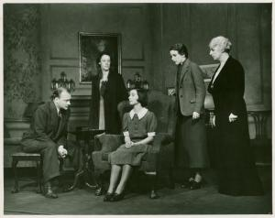

***The Children's Hour*, Maxine Elliott's Theatre, 1934.**

[Billy Rose Theatre Collection, New York Public Library, available at: <http://digitalgallery.nypl.org/nypldigital/id?1607278> ]

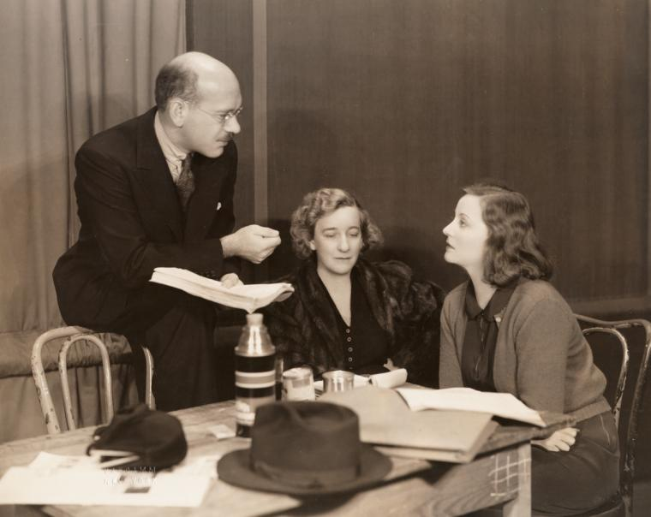

**Producer/director Herman Shumlin, Lillian Hellman, and Tallulah Bankhead (Regina) at a rehearsal for the original production of *The Little Foxes* at the National Theatre in 1939.**

[Billy Rose Theatre Collection, New York Public Library, available at: <http://digitalgallery.nypl.org/nypldigital/id?psnypl_the_5151> ]

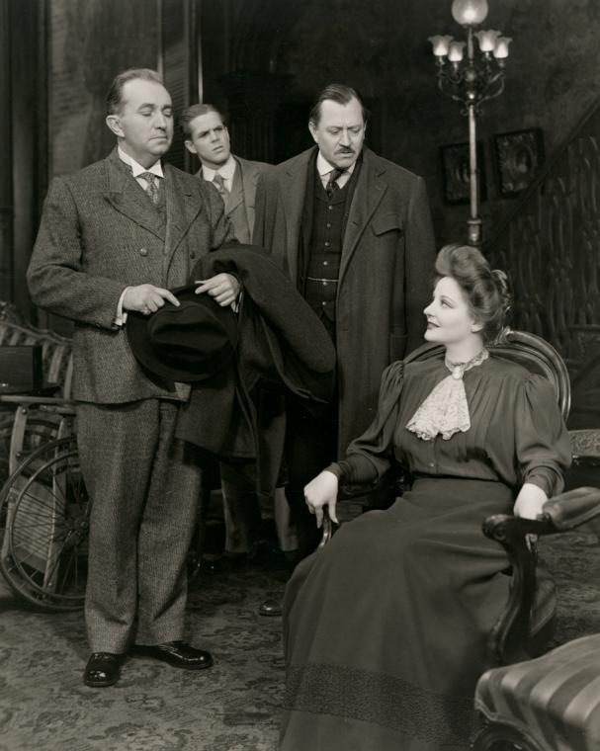

**Charles Dingle, Dan Duryea, Carl Benton Reid with Tallulah Bankhead in The Little Foxes, National Theatre, 1939.**

[Billy Rose Theatre Collection, New York Public Library, available at: <http://digitalgallery.nypl.org/nypldigital/id?psnypl_the_5152> ]